# Flowchart

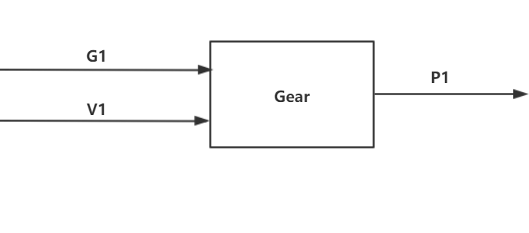

Figure 1 Gear component flowchart

# Table of limits

|  |  |  |  |  |
| --- | --- | --- | --- | --- |
| Interaction | Symbol | Min. | Max. | Unit |
| -> G1 | | | | |
| *Data from motor calculation* | | | | |
| Motor torque output | $$T_{Motor-out}$$ | 0 | 3500 | Nm |
| Motor rotation speed ouput | $$ω_{Motor-out}$$ | 0 | 2200 | rpm |
| -> V1 | | | | |
| *Data from user interface sub-system (input block)* | | | | |
| Gear friction coefficient | $$µ_{gear}$$ |  |  |  |
| Gear transmission ratio | $$R_{g}$$ | 0,1 | 10 | # |
| Gear index circle pressure angle | $$α$$ | 15 | 25 | $$°$$ |
| Gear index circle diameter of driving wheel | $$d$$ | 0 | - | m |
| Gear addendum radius | $$d_{1}$$ | 0 | **-** | m |
| Gear dedendum radius | $$d_{2}$$ | 0 | - | m |
| Gear tooth number | $$z$$ | 0 | **-** | **-** |
| Gear tooth width ratio | $$b$$ | 0 | 1 | - |
| Gear modulus | $$m$$ | 0 | - | - |
| Gear immersion depth ratio | $$h$$ | 0 | 1 | - |
| Gear lubricant viscosity | $$μ$$ | 0 | **-** | **-** |
| Gear lubricant density | $$ρ$$ | 0 | - |  |

|  |  |  |  |  |
| --- | --- | --- | --- | --- |
| -> P1 | | | | |
| *Data to bearing calculation* | | | | |
| Gear power loss | $$P_{Gear-loss}$$ | 0 | 8400 | W |
| Gear torque output | $$T_{Gear-out}$$ | 0 | 3500 | Nm |
| Gear rotation speed output | $$ω_{Gear-out}$$ | 0 | 2200 | rpm |